

**A**

**MINI-PROJECT REPORT**

**ON**

**"Tally Trade-Off"**

Submitted in partial fulfilment of the requirement for the award of

**Bachelor of Engineering**

**In**

**Computer Science and Engineering**

**Punyashlok Ahilyadevi Holkar Solapur University**

**By**

**Ayusha Sandeep Bhola TECSE-36**

**Shrutika Sunil Chendake TECSE-37**

**Megha Shivanand Karjol TECSE-38**

**Akshata Shrinivas Machal TECSE-39**

Under Guidance Of

**Prof.Mr.P.S.R.Patnaik**



**DEPARTMENT OF COMPUTER SCIENCE AND ENGINEERING**

**WALCHAND INSTITUTE OF TECHNOLOGY**

**SOLAPUR - 413006**

**(2019-2020)**



**CERTIFICATE**

This is to certify that the Mini - Project entitled

“**Tally Trade-Off**”

Is Submitted By

**Ms.Ayusha Sandeep Bhola TECSE-36**

**Ms.Shrutika Sunil Chendake TECSE-37**

**Ms.Megha Shivanand Karjol TECSE-38**

**Ms.Akshata Shrinivas Machal TECSE-39**

**(Mr.P.S.R.Patnaik)(Dr.A.R.Kulkarni)**

***Project Guide Head***

***Dept of Computer Sci.&Engg***

**(Dr. S .A. Halkude)Principal**

**INDEX**

|  |  |  |
| --- | --- | --- |
| Sr No. | Topic | Page No. |
| 1. | Abstract | 4 |
| 2. | Introduction | 5 |
| 3. | Background | 6 |
| 4. | Technologies Used | 7 |
| 5. | Description And Working | 12 |
| 6. | Screenshot And Results | 15 |
| 7. | Advantages | 21 |
| 8. | Future Scope | 22 |
| 9. | Conclusion | 23 |
| 10. | References | 24 |

**Abstract**

The objective of the project is to develop Textile Marketing. The Textile Industry is primarily concerned with the Design, Production and Distribution of Yarn, Cloth and Clothing. For the project we have visited the textile industry in our area, they talked about their working, production and distribution of clothes and other materials and also discussed if they wanted any help maintaining it. So for this, they were facing problems in maintaining the Yearly Data from Tally also Economic Balance.

The major complication is to maintain data that they are using Tally ERP9 to calculate the Production, Distribution and their Economic Balance and then they export that yearly Data into Excel or pdf format and storing it onto their computer system .And for this they are manually exporting the yearly data from the TallyERP9. The data stored in Excel is not secured i.e. anyone can access the data without administrator permission.

To avoid this we are providing the Desktop Application “**Tally -Trade-off**” that connects the TallyERP9 and Database directly, which helps to keep stored data secured. It helps to show more than one type of data at a time. Using this platform we can use any industry for visualization of data directly.

This Desktop Application provides users to transfer the data from the Tally to Database on just single click. This provides the accountant or user to directly transfer the data to the database instead of storing the yearly data. The owner can also keep a watch into the data being transferred to a particular year and company.

This interface is very useful and economical for the industry to maintain and view the data being transferred from the tally as it is very error-prone.

**Introduction**

Tally Trade-off is developed with the aim to store and maintain the large data of Textile Organization secured. With the idea of this project, we can transfer the Tally Data to the database. The main motto of the project is to establish the direct connection of Tally ERP9 and Database. This Project would be more beneficial for business. In this application, we have transferred all the Trial balance data as well as List of Ledgers data from Tally ERP9 to Database using SOAP API and Http interface.

This proposed solution has the ability to solve the problem of storing the data and maintenance of data. Also, we can decide increment or decrement of products in the business easily with this solution. This helps to see the long term or short term milestone in business.

**Objective and Goals:**

1. To Directly connect TallyERP9 with the Database
2. To implement an efficient and user-friendly application for users.
3. To store the large data in Database without any difficulty.
4. To secure the stored data.

**Background**

According to background study and research completed on “Textile Industry”, problems faced by industries are they have to manually store the data from Tally on a computer system after each financial year. There are many problems associated while storing and accessing the data which mainly are:

* Difficulty in maintaining and accessing data.
* Manual storing of data.
* It is very difficult to maintain historical data and important information in the system and TallyERP 9 which also needs much space to keep all the previous year’s data which includes List of Ledgers, Trial Balance, Sales, Stocks, Production and much more.
* In existing systems industries are only maintaining data in Excel to store the information. And for Viewing a particular company's yearly data and performing the operation on it they need to re-upload company details on-to Tally ERP9 software which is very tedious and time-consuming.
* In this application, users can store the data in the Database on just one click, which is very and less error-prone.
* More manual hours are needed to generate the required reports.

*In order to export Tally data to the database server, we have introduced a product called Tally Trade-off. The primary job of this product is to get connected with Tally and extract, analyze and place the data in the database.*

*The Tally Trade-off connects Tally with SOAP (Simple Object Access Protocol) API, that is, a messaging protocol that lets various programs to run on incongruent platforms (Operating Systems) like Linux and Windows using HTTP and XML.*

**Technology Stack:**

Following are the technologies that we are used while developing the project(Both Frontend and Backend technologies)

* **Front End**: JAVA, XML
* **Back End**: JAVA
* **APIs**: SOAP(Simple Object Access Protocol)
* **Database**: SQLite
* **Operating System**: Linux, Windows

**Tally XML interface:**

XML (Extensible Markup Language) is the standard for information exchange with external systems. Tally.ERP 9 supports standardized message formats for Request/Response. Tally.ERP 9 can communicate with any environment capable of sending and receiving XML over HTTP.

Tally can act as an HTTP server capable of receiving an XML Request and responding with an XML Response. The entire Tally Data can be made available to the requesting application. It is also possible for the application to store data into Tally Database. The XML documents contain the action to be performed and details of Tally Data on which action needs to be performed.

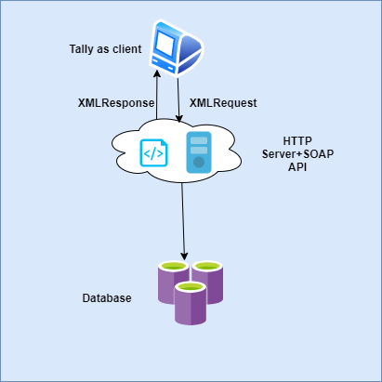

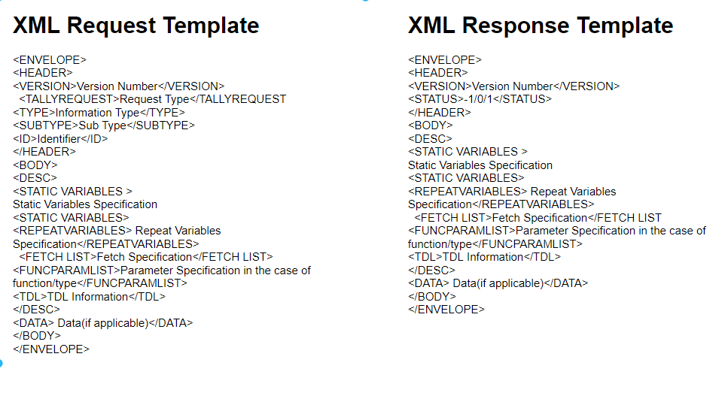

**SOAP API:**

SOAP (abbreviation for Simple Object Access Protocol) is a messaging protocol specification for exchanging structured information in the implementation of web services in computer networks.SOAP uses the standard HTTP request/response model. The server uses a “Listener” to process SOAP requests.

SOAP is a Protocol which is used to interchange data between applications which are built on different programming languages. SOAP is built upon the XML specification and works with the HTTP protocol. This makes it perfect for usage within web applications.

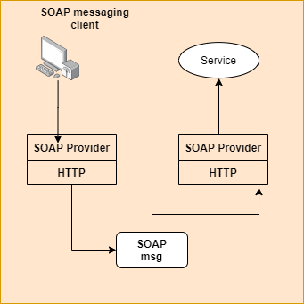

**SQL:**

SQL i.e. **Structured Query Language** is a standardized programming language that's used to manage relational databases and perform various operations on the data in them. The uses of SQL include modifying database table and index structures; adding, updating and deleting rows of data; and retrieving subsets of information from within a database for transaction processing and analytics applications.

Each column in a table corresponds to a category of data -- for example, customer name or address -- while each row contains a data value for the intersecting column.

* **WHY XML INTERFACE?**

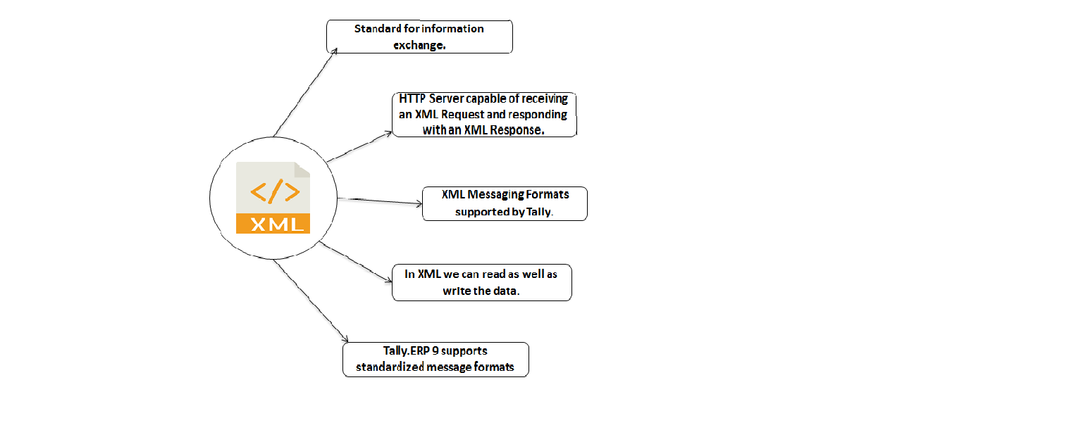

**Software:**

* **Tally ERP 9:**

Large and medium-sized businesses use disparate applications to run their business and one of the major areas that need to converge amongst these applications is the Accounting, Financial and Inventory information. Tally being the default accounting, Inventory and Statutory Compliance software used by enterprises in these segments.

**Features and Highlights:**

**Features:**

* Keep a record of inserted data as well as previously saved data.
* SQL record contains fields like Company name, date, Trial balance, List of Ledgers.
* The owner can see the data of the Database on the basis of company name and date.
* We can update the data.

**Description and Working of Project**

**Architecture:**

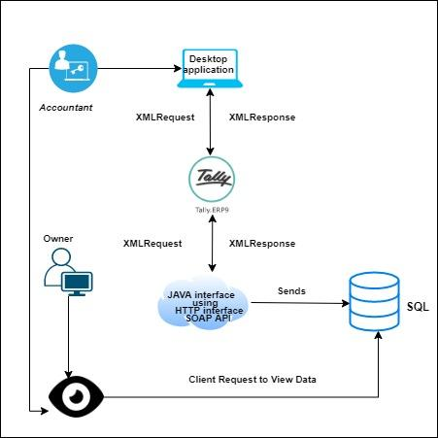

**Working:**

* First of all, the Administrator has to register on the system and enter the following details:

Name. Username, Email Id and password.

* After registration, Admin can log in on the system by using his username and password.
* After logging in, the admin must provide all the remaining information which is needed to be filled such as port number, company name, financial year and which type of data they want to see etc.
* After providing the above information they can see the data as per their request.
* User can log in through the user portal.
* After logging in they have to provide the company name and financial year then go to the view data.
* The requested data will be view in database.i.e. in table format.

**Description:**

* Tally Trade-off is a software used to connect Tally and Database directly with the help of XML request-response interaction through HTTP interface using SOAP API.
* It will help the Textile Industry to keep the Data of all Companies on the Database and easily accessible.
* Tally Trade-off system is very easy to use and a user-friendly application.
* There are many features which will help the owner of the industry as well as industry to have confident saved data

**Screenshots and Results**

* ***Homepage & Sponsor’s Information Page***

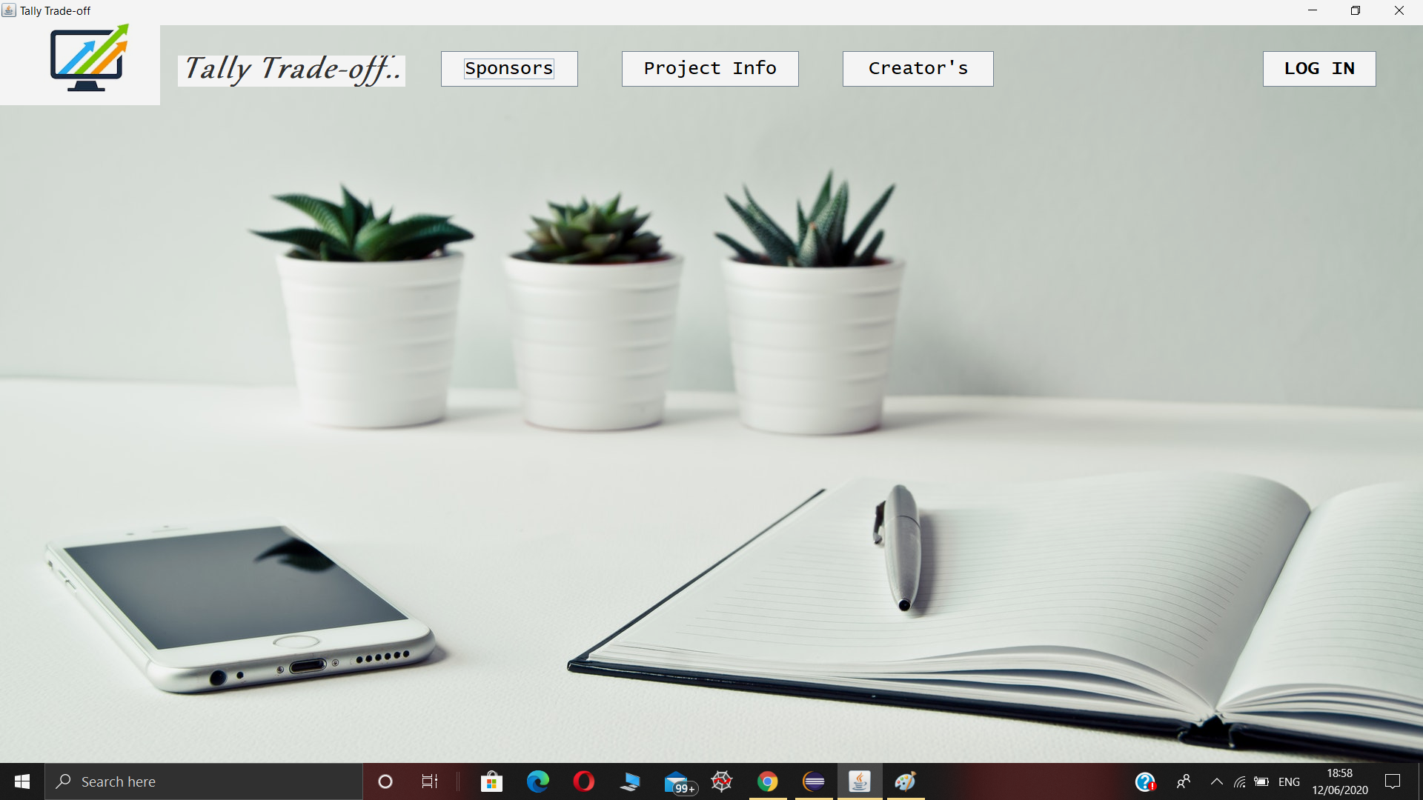



* ***Project Description and LOGIN Page***

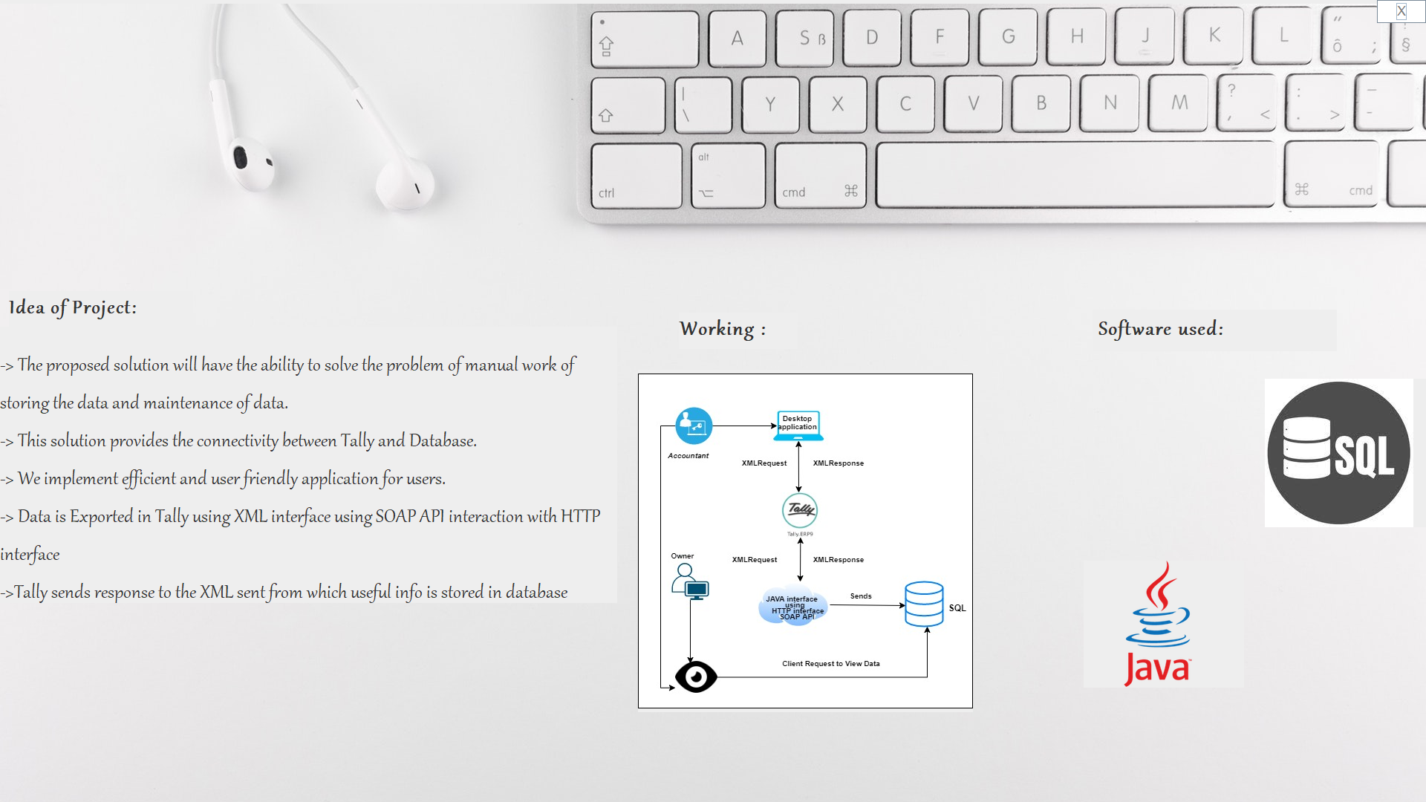

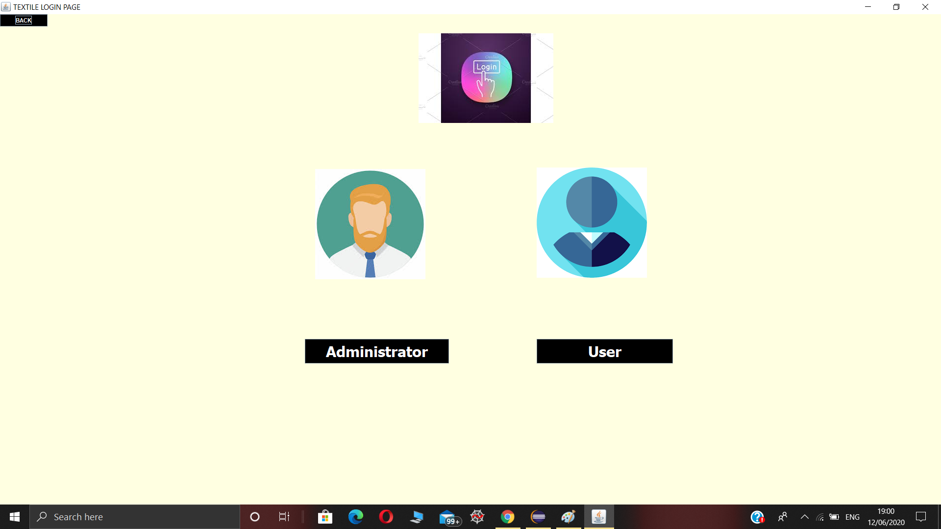

* ***Administrator LOGIN & Registration Page***

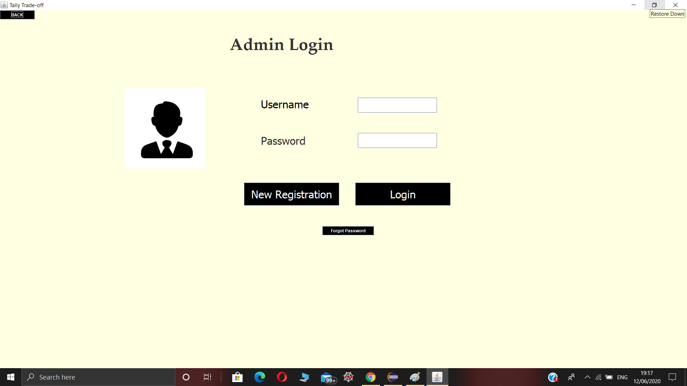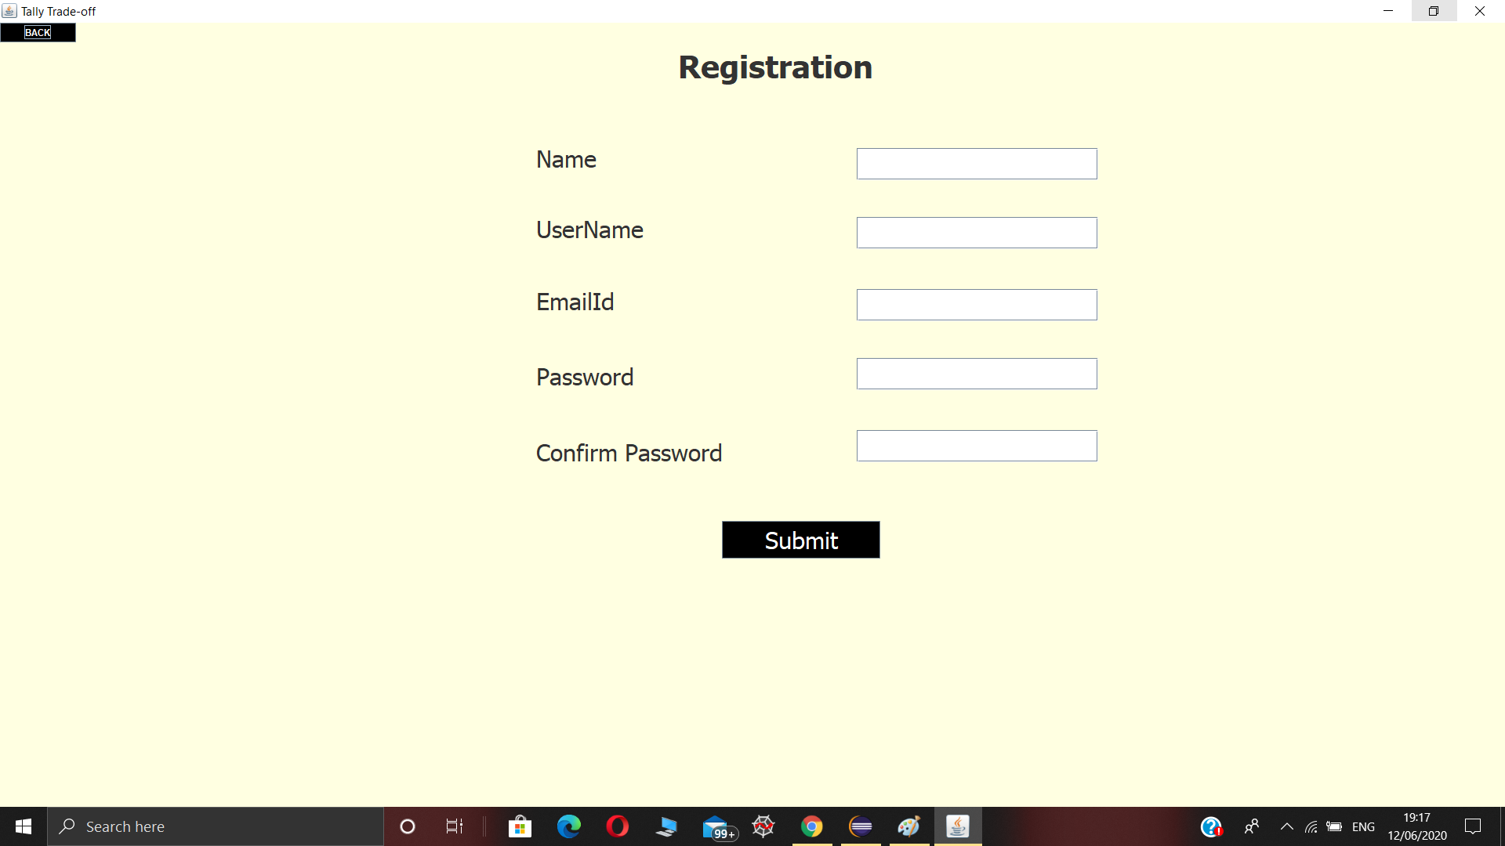

* ***Tally Connection & View Data Page***

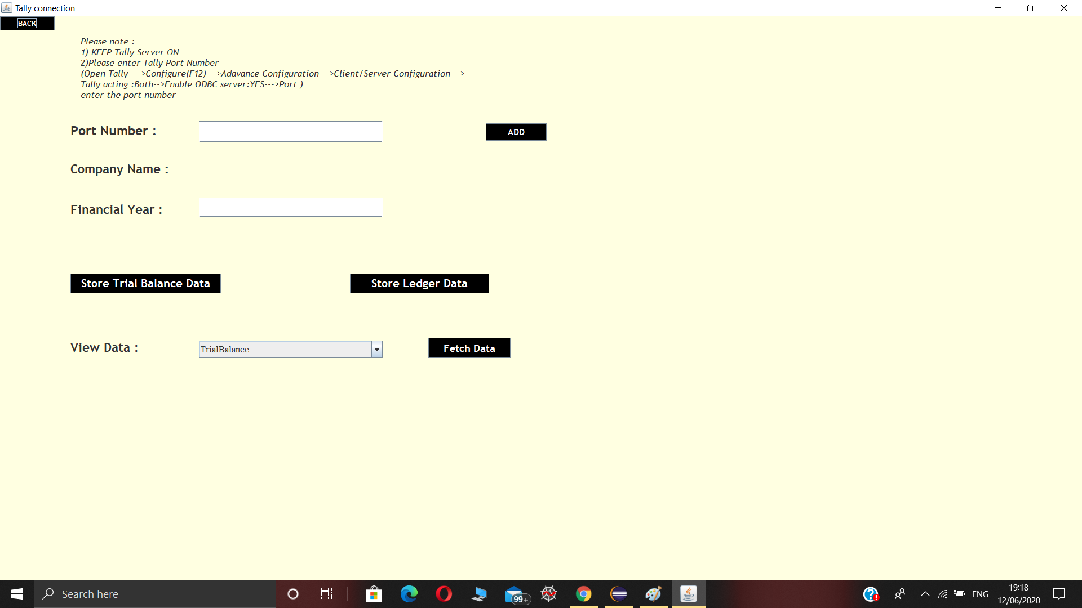

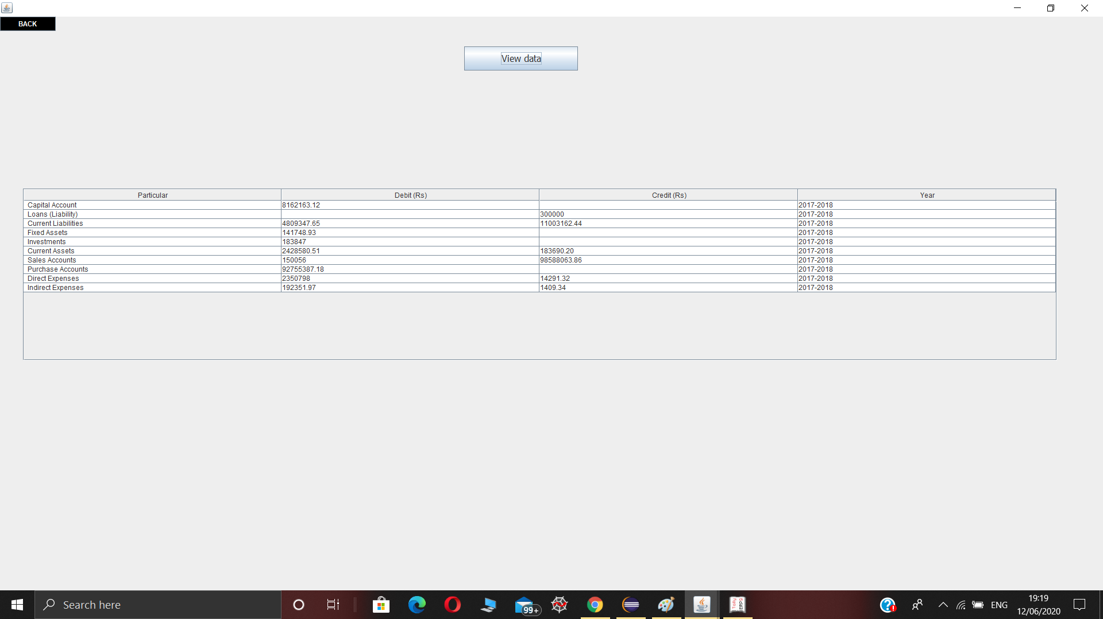

* ***User LOGIN & User View Page***

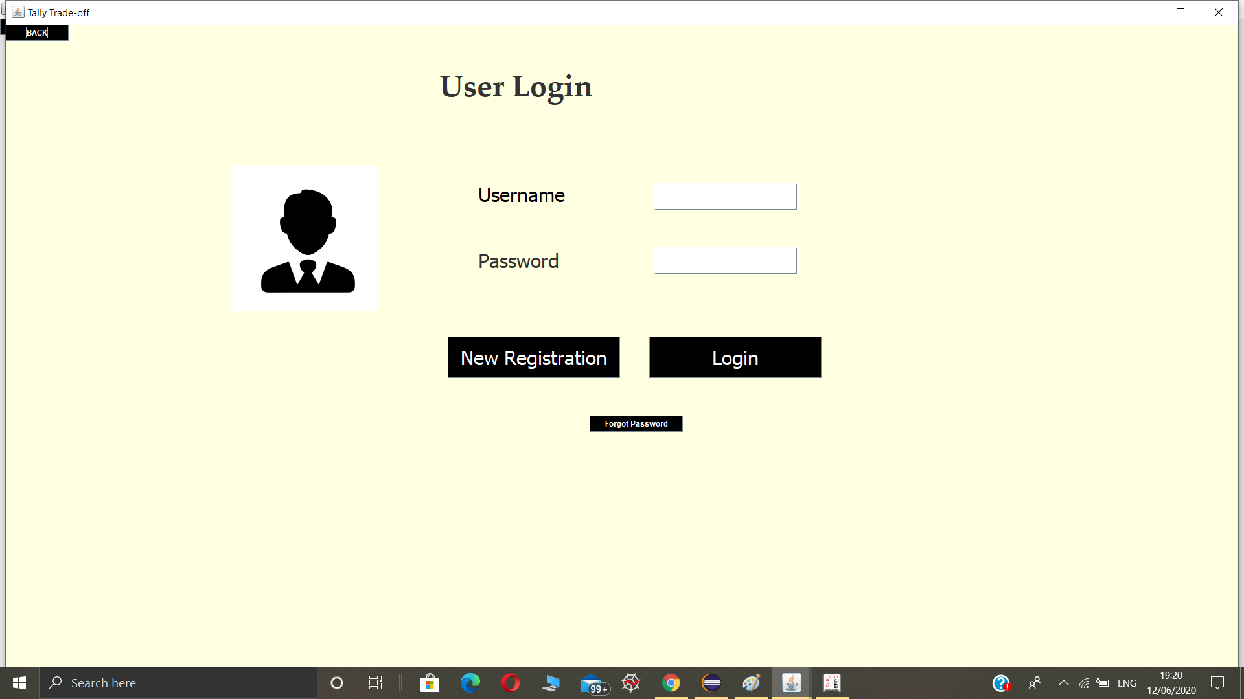

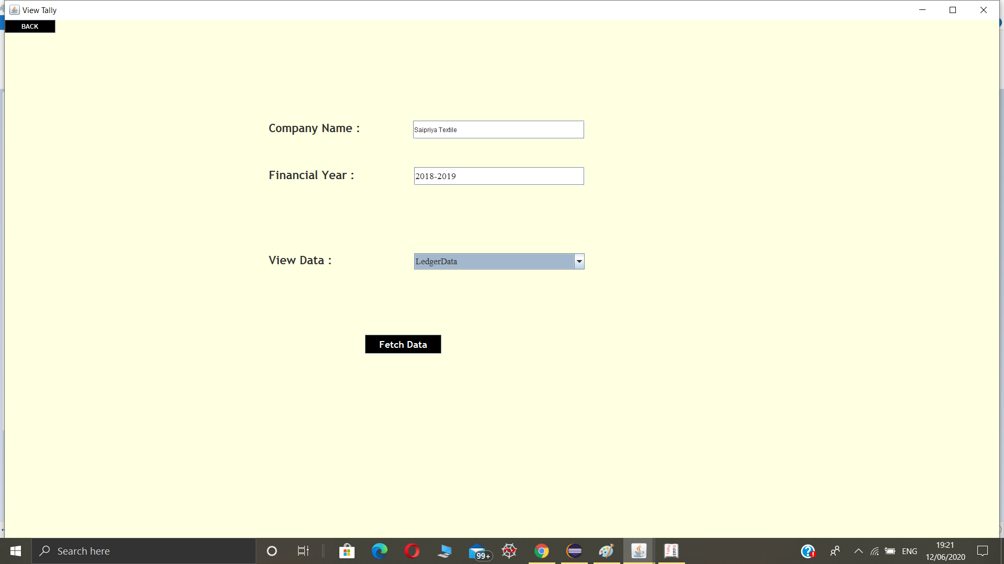

* ***Our Team***



**Advantages:**

* Large data can be stored in the Database without any difficulty.
* Easy and interactive interfaces.
* Separate Log in the window for Administrator and user.
* The solution provides connectivity between Tally and Database.
* It mainly has easy entry of data while fetching and also while updating the data.
* It saves a lot of time of the accountant and owner which was earlier wasted while retrieving any data.
* The data stored in the database is secured.

**Future Scope**

* It can provide a facility for admins to login and can take a glimpse of their industry’s data.
* This product can be made available for every textile industry or owners for storing the data and easily accessible.
* In future, this application will include Direct connect to TallyERP9 and database and also reduce the manual work from the industries. Which will be easy for the Textile Industry.
* In future, we can add area-wise distribution of products field where all the distribution of products can provide to their respected area.
* This product will also provide a facility for showing profit or loss by the graph.

**Conclusion**

The application developed to help Textile Industries to store large size of data in the Database and easy to access these data in Database. This platform helps admins and users to fetch the data and Visualization of Data. This system is suitable for both small and large textile industries. It also maintains year-wise data records in the Database.

It also shows the all required data to be display. This application helps the industry to maintain the track of their informative data. The main motto behind this project is to eliminate the problem of storage of large-sized data and provided a platform to display year wise and required data to the owner or user of the textile industry.

**References**

* <https://youtu.be/XPVucWEE93w>
* <https://help.tallysolutions.com/article/Tally.ERP9/Data_Management/DM_TE9_Outward_Connectivity.htm>
* <https://www.smartsight.in/technology/how-to-integrate-your-tally-data-with-database/>
* https://socia;.msdn.microsoft.com/Forums/en-US/0224666c-252c-44b5-963a-1b0b015cf327/how-to-export-from-tally
* <https://www.tutorialspoint.com/soap/index.htm>
* <http://www.rtslink.com/download-tally-xml-tags.html>